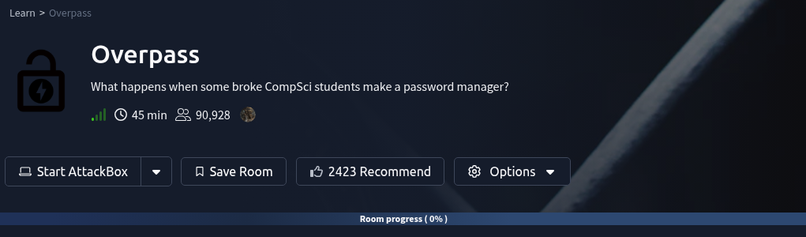

By: Malachi Plamann
Date: 1/7/2026
Link to CTF: https://tryhackme.com/room/overpass
Difficulty: Easy

Objectives:
- What is the User flag?
  - thm{65c1aaf000506e56996822c6281e6bf7}
- What is the Root flag?
  - thm{7f336f8c359dbac18d54fdd64ea753bb}

Target / Host:
10.64.130.192

Engagement Overview:
We have a note mentioning Computer Science students who made a password manager. Nothing else really noted so we can assume it's going to be a penetration test of a simply made password manager.

Writeup:
Let's first start off by running a Nmap scan of the target host to discover the open ports and services.
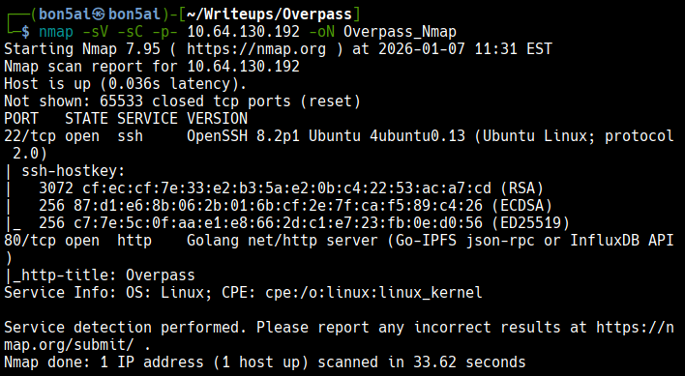
This target only has 2 open ports
22 - SSH / OpenSSH 8.2p1 Ubuntu 4ubuntu0.13
80 - HTTP / Golang net/http server
Let's visit the HTTP service on port 80
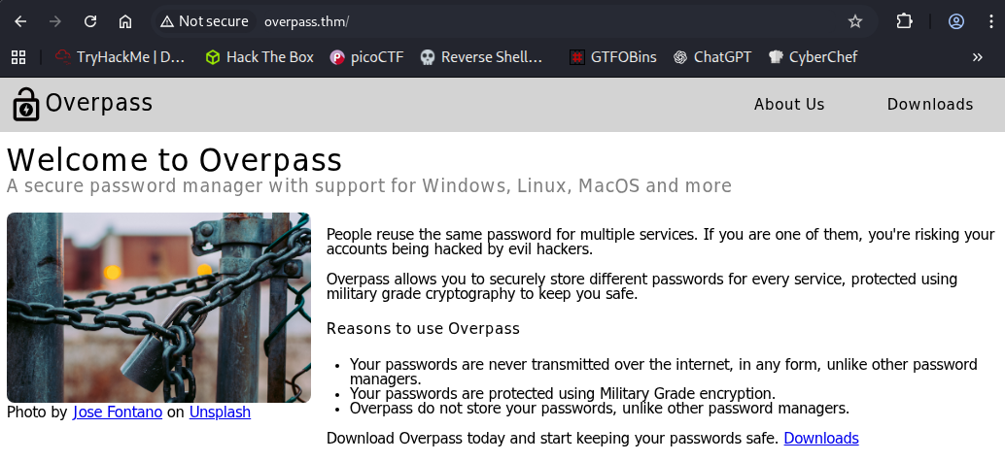
We have a pretty basic looking home page on this website with an About Us and Downloads page.
Hidden in the page source of the home page we have a note left on line #38
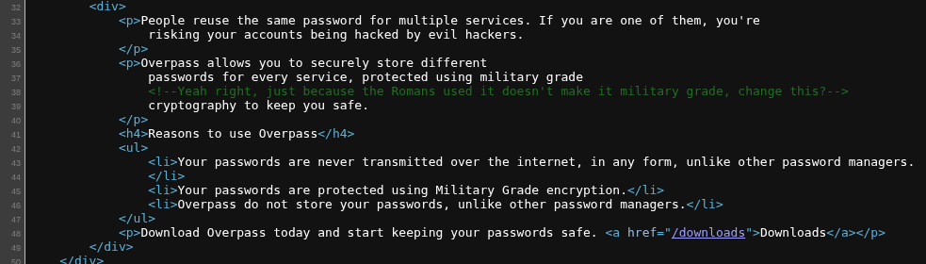
Interesting, we may now have a clue on what encrypting method is used by the password manager.
The most famous method is the Caesar Cipher which was used by Julius Caesar for military messages of the time.
Let's keep that noted as we continue to look further.
The /aboutus page provides some pretty valuable information regarding potential usernames.

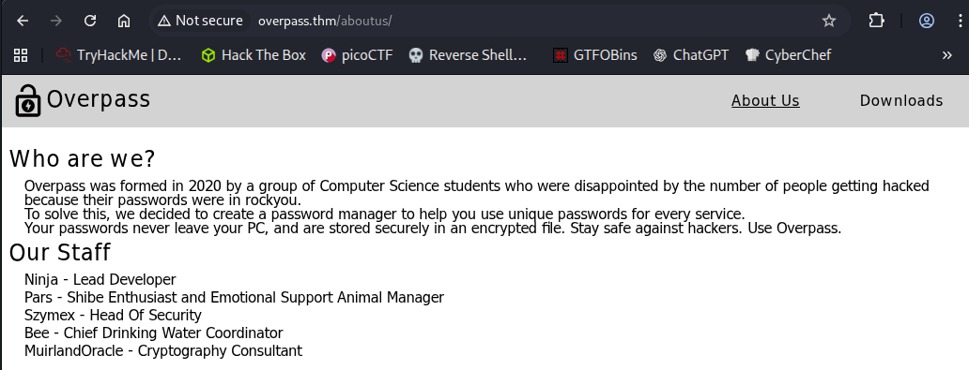
Here we have 5 users listed under Our Staff. The staff members are listed under handles rather than real names.
We also have a note about the rock you password file.
Finally let's take a look at /downloads
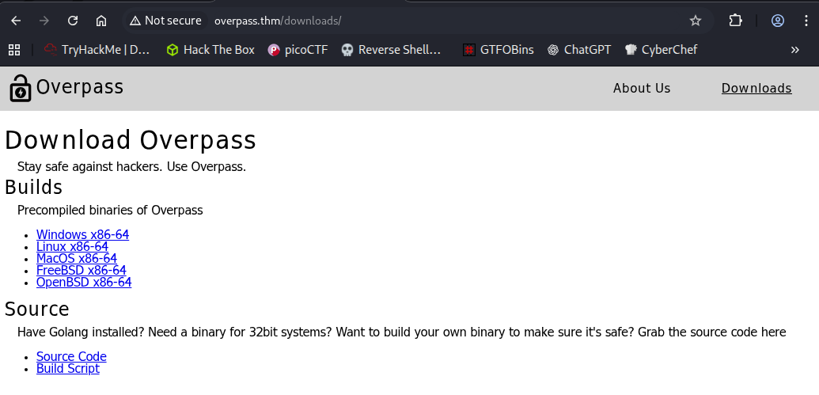
Here we have basic builds but we also have a like to Source Code.
Let's view that and see what we can find.

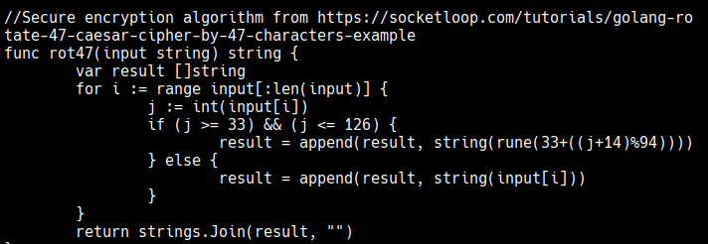
We can see the use of ROT47 in the password manager which is not secure.
This line in the script also confirms it:
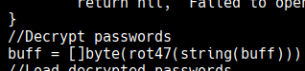
We can also see the main credential path.
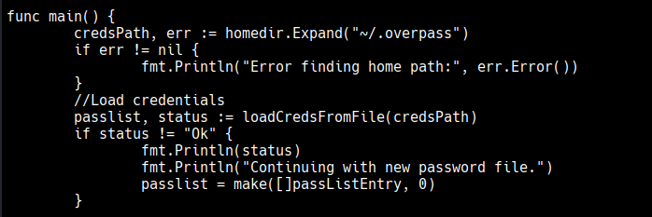
This function shows the path at ("~/.overpass")
From reading the source code I can see a potential exploit of finding the contents of the .overpass file, then decrypting using ROT47, once decrypted it should give us the clear text passwords.
Looking at the hint for the User flag tell us that we should NOT brute-force.

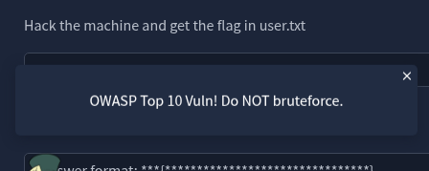
The hint rather points us in the direction of the OWASP top 10.
Since we've enumerated everything we can from the upfront webpage, let's use Gobuster to try and enumerate other web directories.
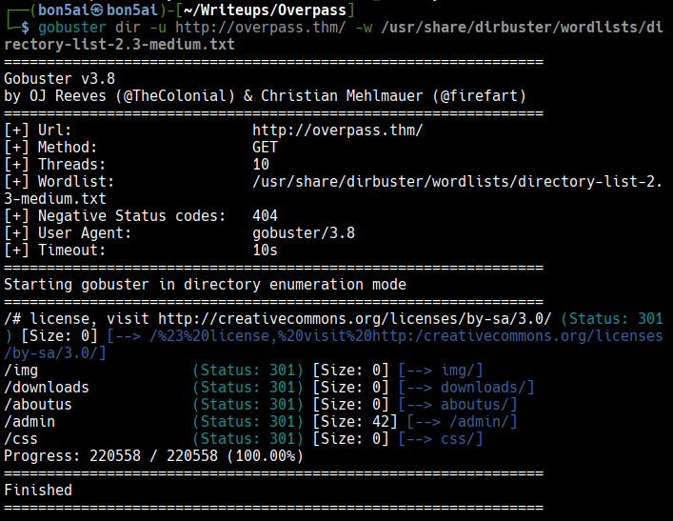
The results of the enumeration provided a new directory at /admin.
Let's visit that and see what we have.
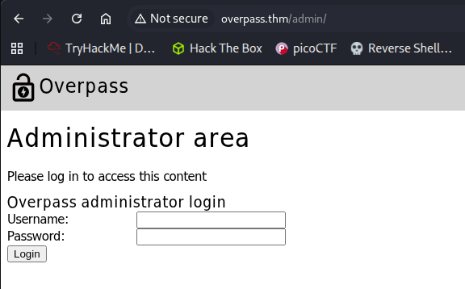
Sweet, we were able to locate the admin login page.
In the page source I found 3 java script files being called.
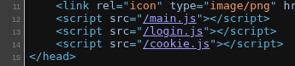
Upon looking further, the login.js script is pretty interesting.

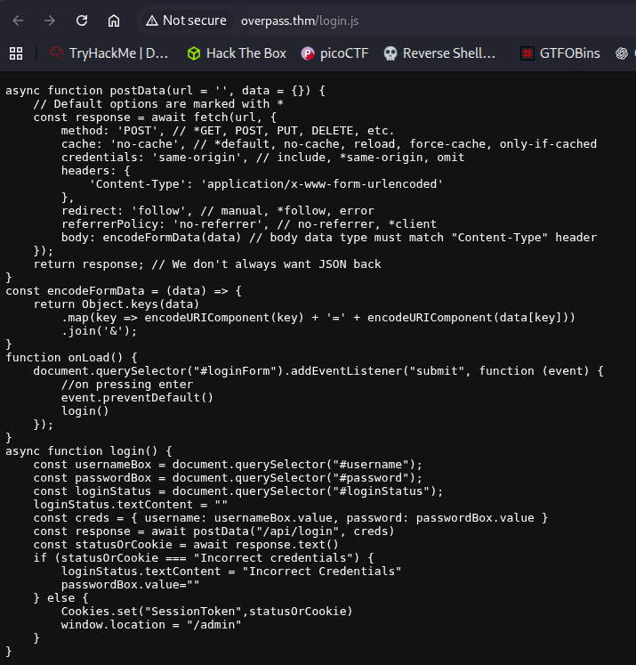
This looks like the login script waits for the response of the login data from /api/login, then once the response comes back it's set as a cookie.
Now that we understand what's happening when a login attempt is made, let's continue.
Since we know that brute forcing is not an option, let's take a look at the OWASP top 10.

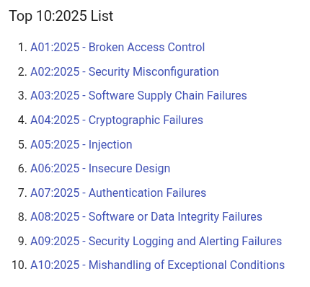
Broken Access Control is number one, let's see if that's something we can exploit on our target.
Something commonly tested is cookie manipulation.
We can test for that using the Firefox browser and the in browser terminal by using the Cookies.set function from the login script and passing a random string through it
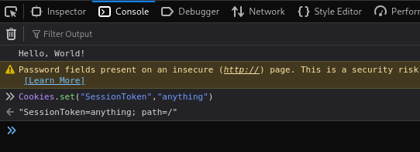
Nice, that seemed to set properly. Now we can refresh the page and see if we have access.

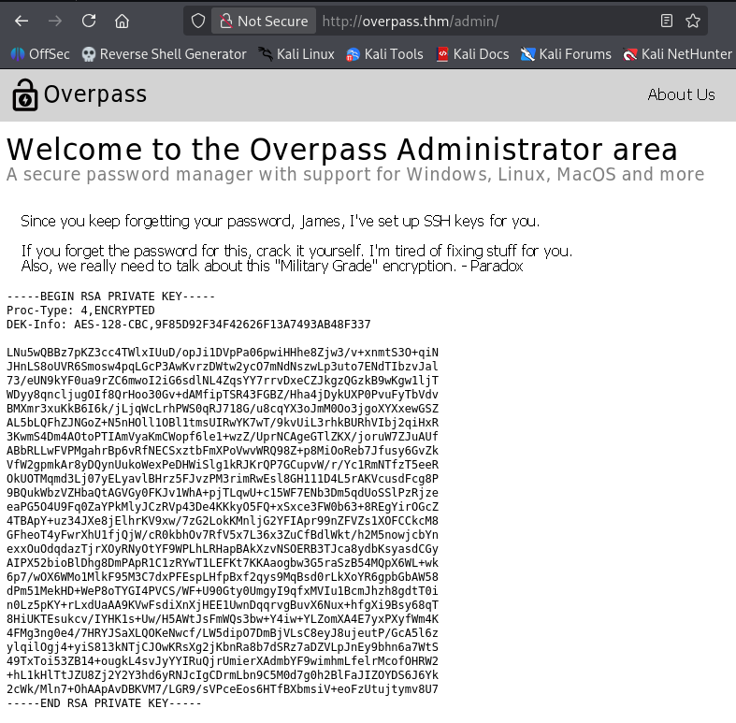
That worked!
We now have a RSA PRIVATE KEY for a user named James.
Along with that we have another username: Paradox.
The note also mentions the need for a password on the private key and to crack it.
Let's save the key to our local machine and crack the password using john.

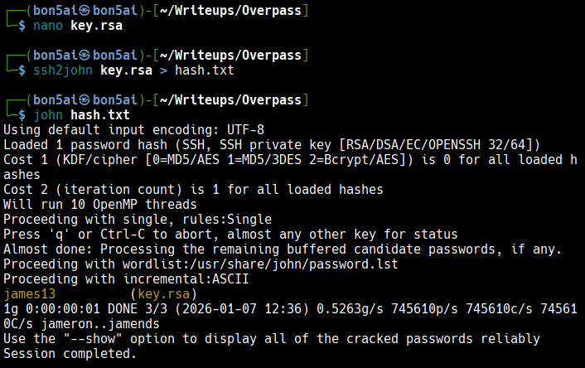
This process is incredibly easy to do, the first command creates a RSA file on our local machine containing the key found for James. The next command formats the key to a hash that the tool John can read. The final command calls the John tool to crack the hash to finally give us the password.
Let's connect to a SSH terminal as James using the new key!
*Don't forget to change the permissions on the key.rsa file to a private key permission set*

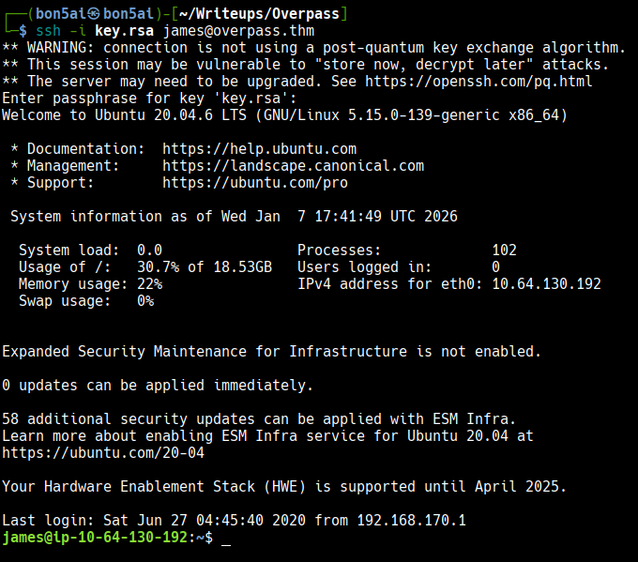
Now we have a full SSH session as the user James!
Let's look around.
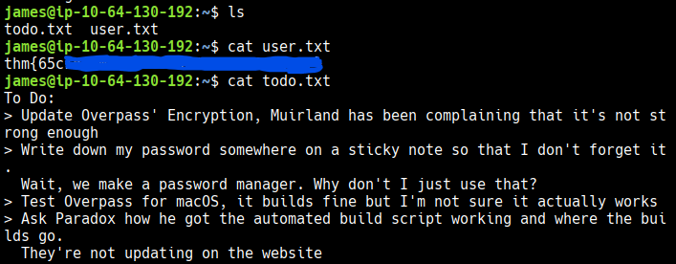
We found the User flag located in James' home directory!
At this point we need to pivot to a root user to access the root flag.
Let's start by checking for Sudo permissions.
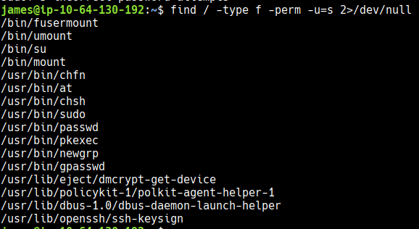
Nothing found here.
If we look at the todo.txt note we have, we may have a hint that we may be able to view the overpass file which contains the passwords!
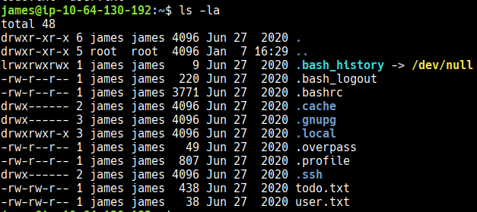
We have the .overpass file!
Let's view the contents.

Since we know it's encrypted using ROT47 we can decrypt pretty easily using CyberChef!
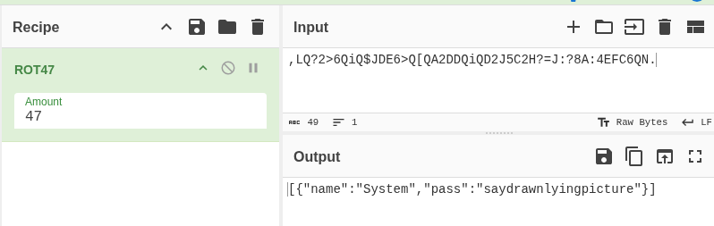
Now we have James' password!
Let's see what files we have permissions to!
This is the first one that came up. We have write permissions to the hosts file!!
Let's finally check for Cron jobs to see if we have any.
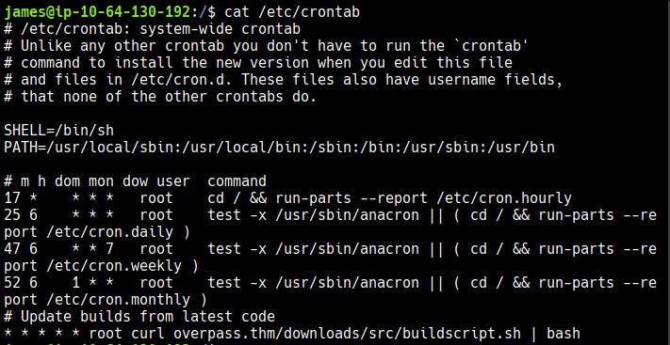

We have one that's interesting, there's a job that calls the buildscript.sh file from overpass.thm
Since we have write permissions to the /etc/hosts file we should be able to change the IP to ours and then mirror the file path with a malicious buildscript.sh file to be ran as root.
Let's try it!
First we mirror the directory path on our local machine
Then we create the buildscript.sh file and add a reverse shell payload from revshell.co
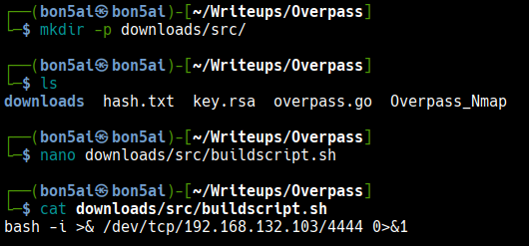
Now we can setup a reverse listener through netcat
Once that's done we can setup our python server so the file can be transferred when the cron job calls for it
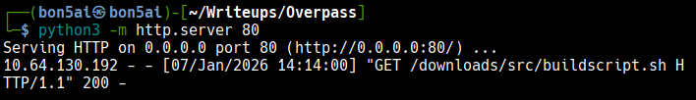
The final step is to change the IP of overpass.thm to our IP on the target machine.
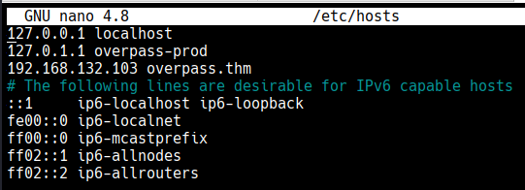
Now all we have to do it wait for a response on our netcat listener!
And we got a connection immediately!
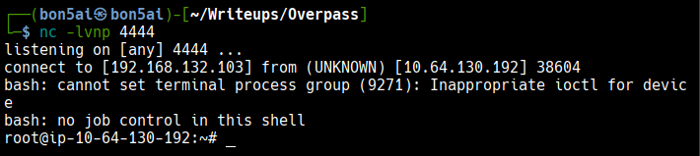
We now have a session as root on the target.
From here we can enumerate further.
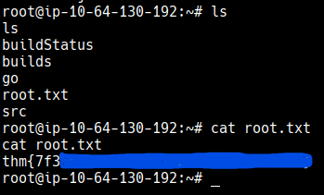
The root flag was found in the Root's home directory!

